Your folded origami cranes used in a 1001 crane artwork is jaw dropping awesome. Reviews rated this design as one of the top 10 in 20+yrs here at OrigamiDesigns.
-------------------------------------------------------------------------------------------------
Possibilities: foil crane color: gold, silver, red, blue
Chose color of the mandala pattern, and color black, white, gold, bronze, silver
Depending on the choice for your foil cranes & pattern color THEN choose a background color.
Gold cranes, blk or gold pattern, black or gold background for example
Silver cranes, blk or silver pattern, black or white background for example
Red cranes, blk pattern, black background for example
Silver cranes, white pattern, white background for example
Gold cranes, bronze pattern, blackground for example
Blue cranes, wht or silver pattern in white background.
Choose the pattern you like (with colors available)
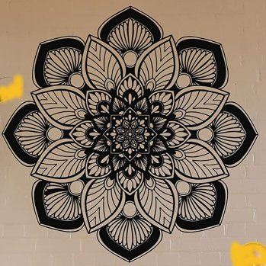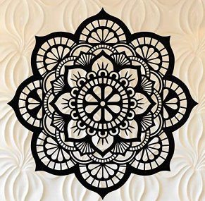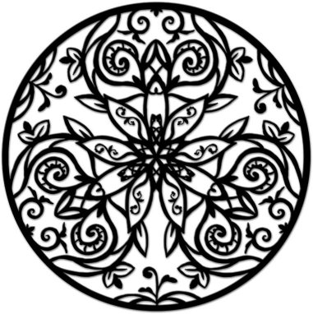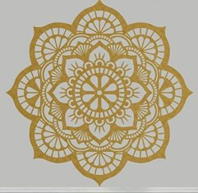
Black 1 black 2 black 3 gold
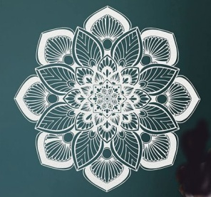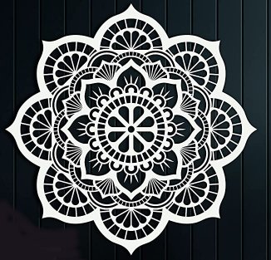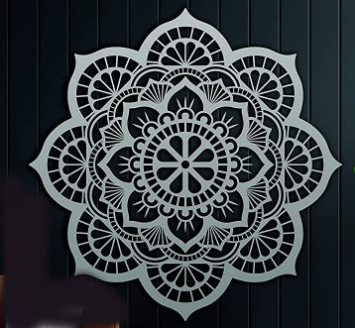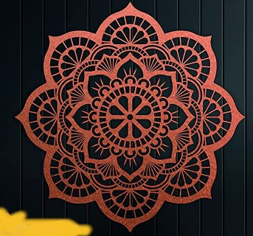
White 1 white 2 silver bronze 1
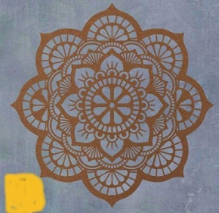 bronze 2 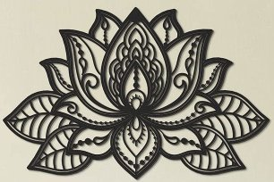 black lotus

